# 

# 

# 

# PATAN COLLEGE FOR PROFESSIONAL STUDIES

# Individual Reflective Report

# Python Project

# 

# Shahu: The Ultimate Shared Power

# PROJECT REPORT

# Submitted by Submitted to

# Kshitij Bajagain (1723333) UOB

**Individual Reflective Report**

This form is submitted by every member of your group and used to assess the level of teamwork in your group and the contribution of individuals. It may also form the basis of discussions which affect the grades received by individual group members.

|  |  |  |  |
| --- | --- | --- | --- |
| Student Number | First Name | Last Name | Group No |
| 1723333 | Kshitij | Bajagain | 10 |

Pursuing programming was always my passion and after passing my intermediate level, I was in dilemma of choosing the course which will help my passion to be my profession. After lots of research I made my mind to get enrolled in this course offered by University of Bedfordshire. I already know that this course is all about developing software. In level 4 SEM –I, University of Bedfordshire assigned the python group project Shared Power. Before choosing a group I was in confusion whether I can work efficiently in team or not but due to group members Dinesh Timalsina, Ram Ghimire and Anupam Dhakal , my confusion was over. We divided work into equal ratio for every member regarding every software development phase. I am proud to say that we worked with scheduled work division in perfect time which resulted good working functional as well as attractive software.

As we have already mentioned in group report about group organizational role of every individuals members. According to that group role my role was a developer and I have put my maximum effort on proving my group role as a developer. Following group division was assigned in group:

|  |  |  |
| --- | --- | --- |
| **S. N** | **Name** | **Work Division** |
| **1.** | Kshitij Bajagain | Brainstorms, User Panel ,Upload Tools , Search Tools,, Hire Tools, Class Diagram, File handling(FH) |
| **2.** | Anupam Dhakal | Research, Login , Register, UML Diagrams(Sea level, Fish Level), Presentation Slides |
| **3.** | Dinesh Timalsina | Return Tools, Payment , Invoice Generation, Clam level Diagram, Testing of software |
| **4.** | Ram Prasad Ghimire | Insurance agent profile design and development, Activity diagram, Analysis of software |

Every member has done their job perfectly but especially during development phase of software, some confusion was there but it was over after some group discussions. As mentioned in above group division, I did my job of developer but during development there were some difficulties that I faced .The main difficulties was team member co-ordination , but still group division was assigned perfectly which resulted in good software.

Below I have attached the work that I have done during software development.

1. **Brainstorms** :

Brainstorms are always important during development phase of software. Everybody helped me to figure out how to design functions and implement those in software.

2>**Coding Part:**

My role during software development was back-end coder; I developed User Panel for registered user. Similarly, the functions used by registered such as upload tools, search tools, hire tools and logout function along everything inside the user panel (i.e. calendar function, upload image function).

**3>UML Diagrams:**

As per the work division, I did CLASS DIAGRAMS and used OOPS (Object – Oriented Approach) for developing functions that was assigned to me by group leader Anupam Dhakal.

**4> File Handling**

File handling was integral part of software development which was assigned to me and I did it in normal python file handling (read, write, delete etc.)

In group, every member worked perfectly and evaluating their work I have attested a table below which rates their work during project development.

|  |  |  |  |
| --- | --- | --- | --- |
| Student Number | First Name | Last Name | Contribution  (N,S,I) |
| 1815429 | Dinesh | Timalsina | S |
| 1816707 | Ram | Ghimire | S |
| 1815430 | Anupam | Dhakal | S |

**S** -Significant (The group member’s work was integral to the overall submission)

**N** -No Contribution (The group member took no part in the project submission)

**I** -Insignificant (The group member’s work made little difference to the overall submission)

At last ,I am so proud that my group successfully did the project .It was great opportunity working with awesome team-members (Ram Ghimire, Anupam Dhakal, and Dinesh Timalsina) during this python project (Shared Power) development. I had incredible time working with my team member. Especially I love to thank Dinesh Timalsina for producing high resolution images which was the basis of software GUI .

**Work Divisions Snippets**

**These are following snippets of my work division which I did during software development..**

1. **UML Diagrams(Class Diagram)**

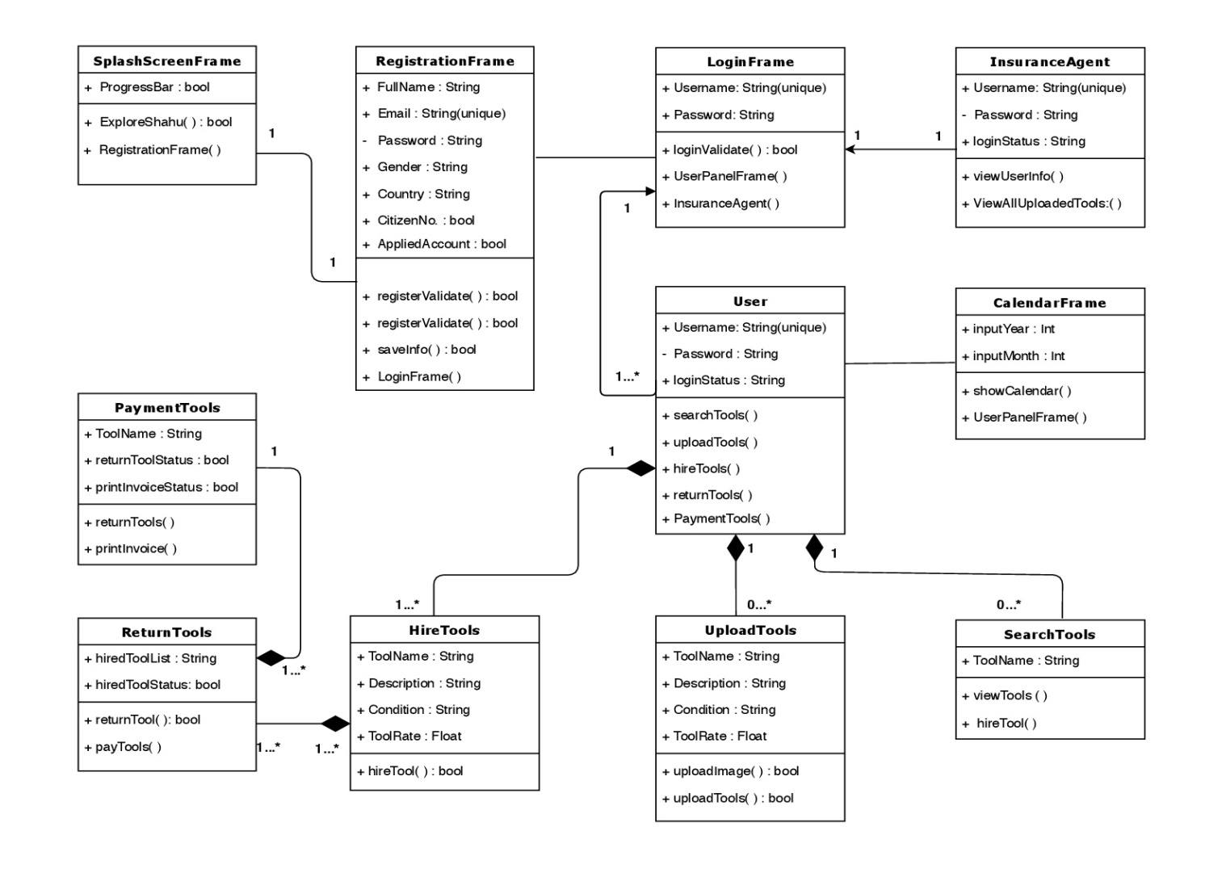

1. 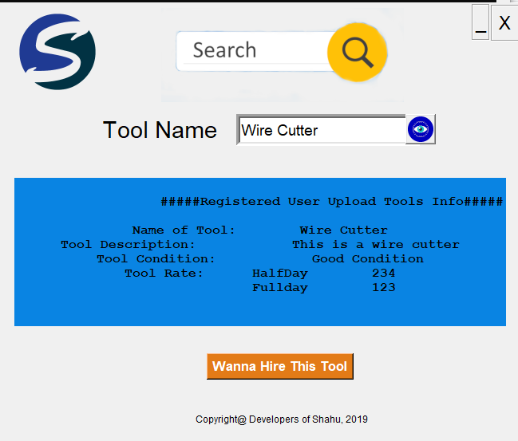**GUI Templates which I did:**

These are the functions that I have did during software development

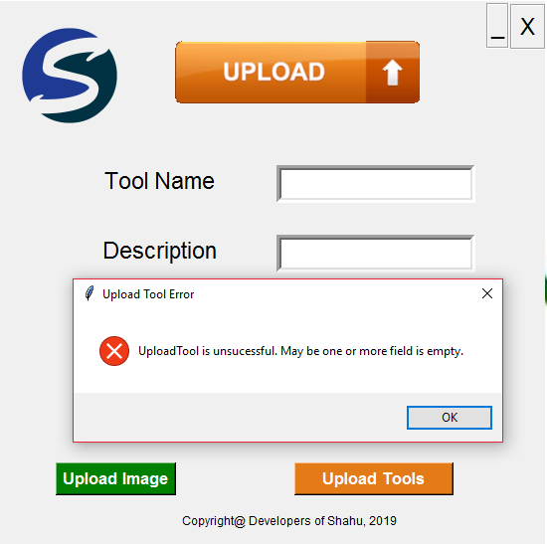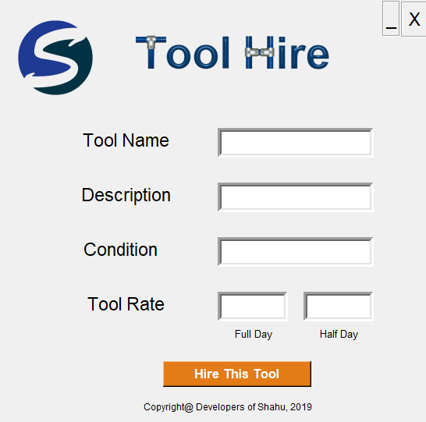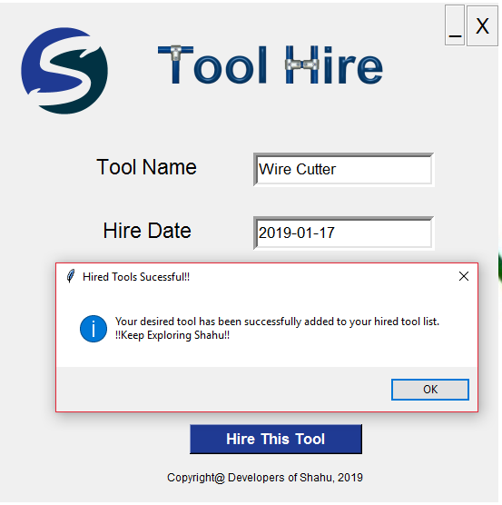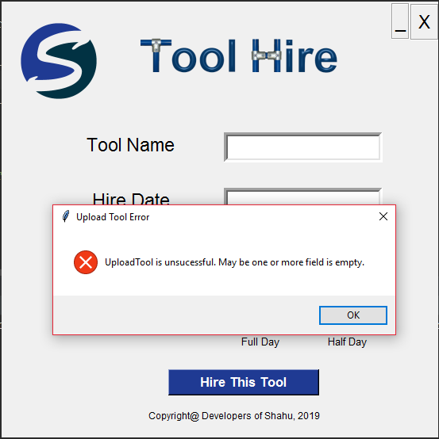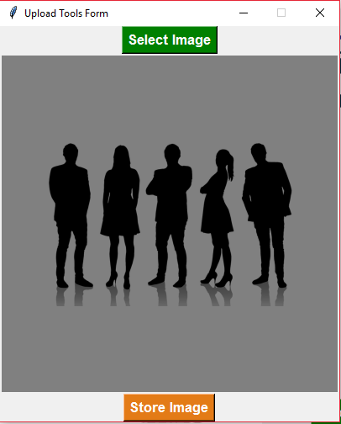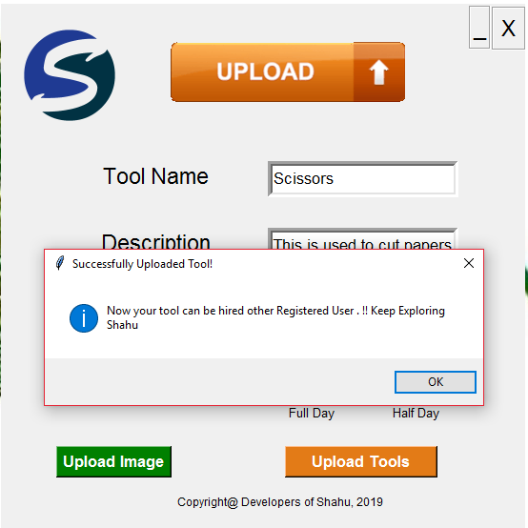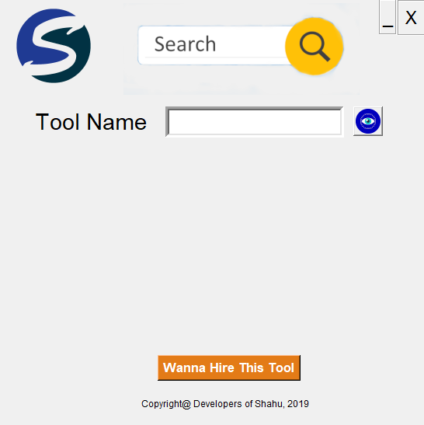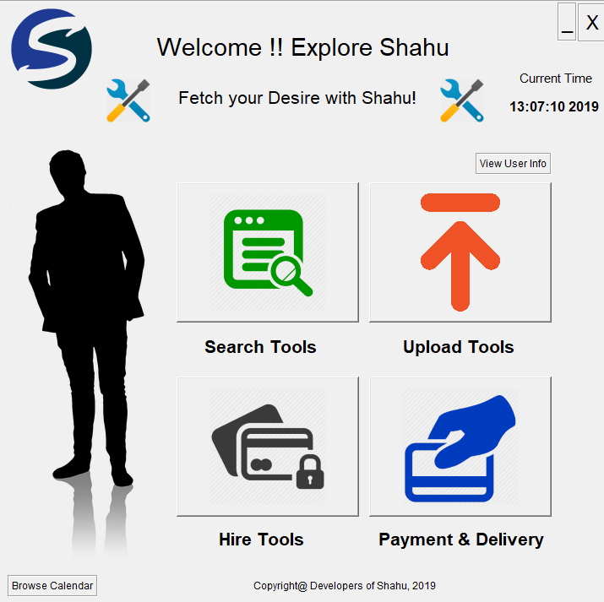

1. **Codes Snippets:**

1>User Panel Codes:

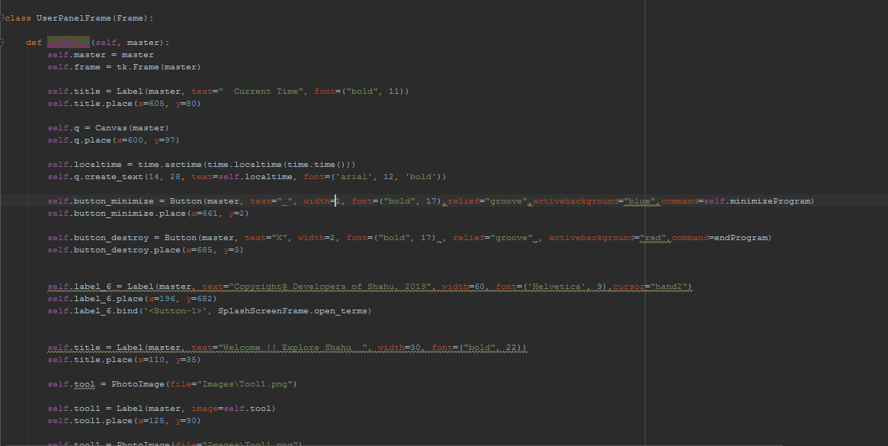

Functions that will redirect user to respective search tools, add tools, hire tools and other functions.

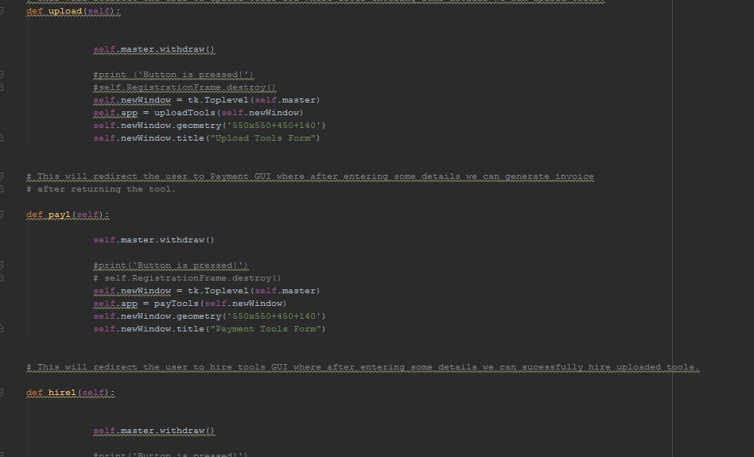

2>Upload Tool Function

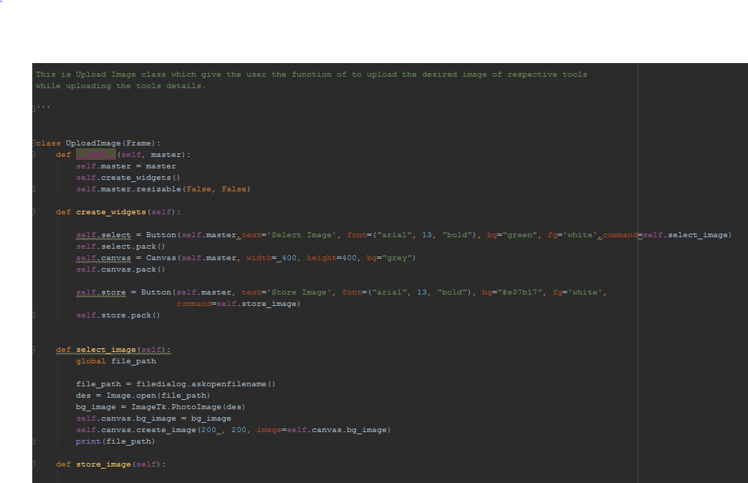

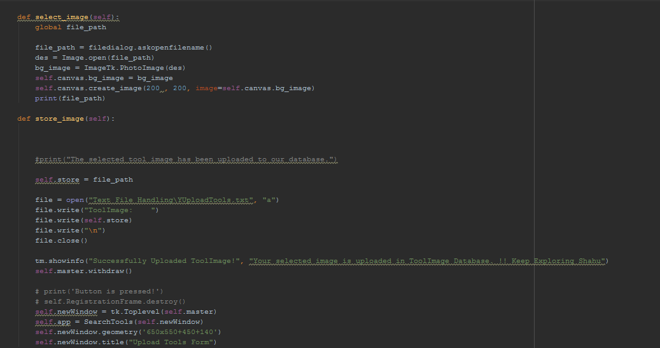

3>Search Tools

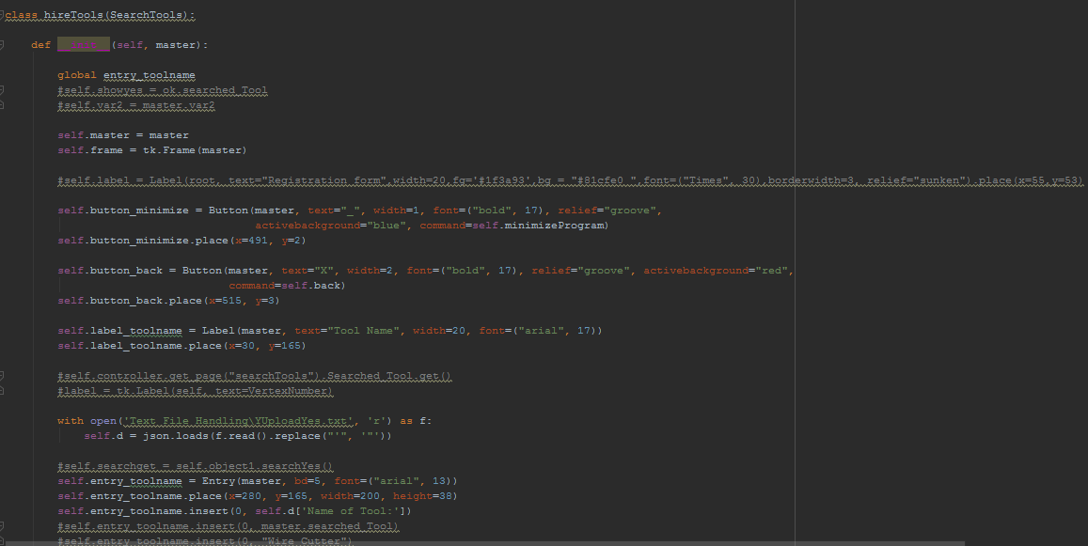

Search results code:

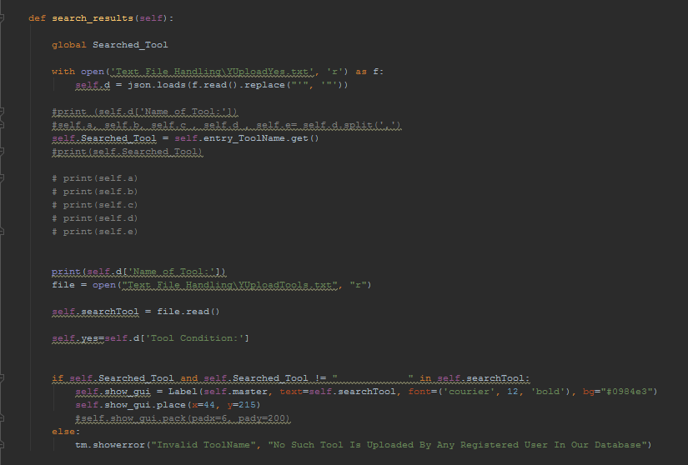

1. Hire Tool Functions

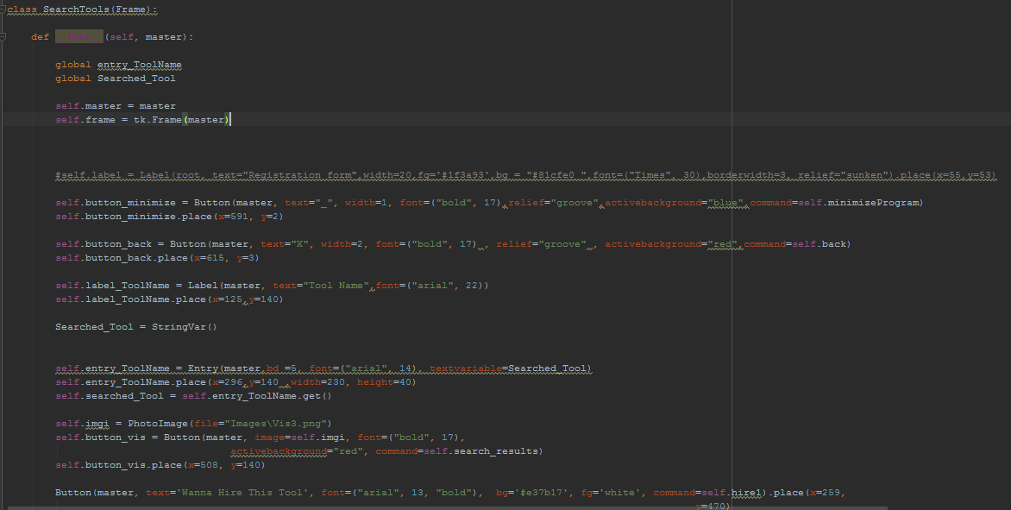  
6>Calendar Class

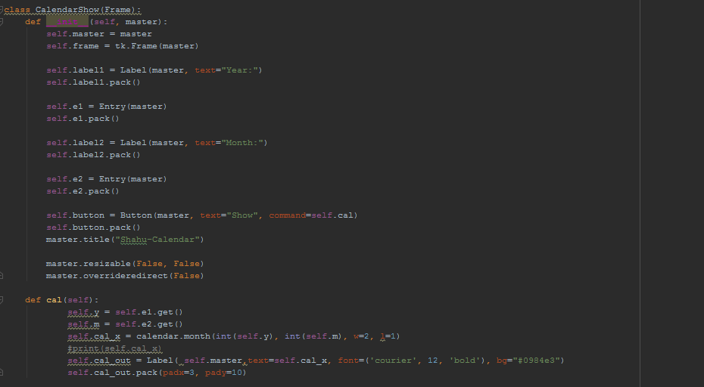  
**These are screenshots of codes that I did it but whole version of code is submitted in along with group report.